In this book I will discuss the power,success,geographical importance and some other affairs of pakistan

Composed by;

AQSA MOHSIN

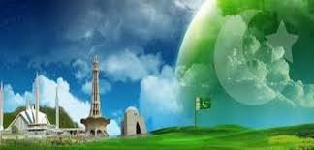

I am Pakistan

***index***

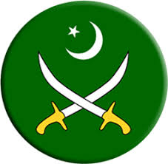

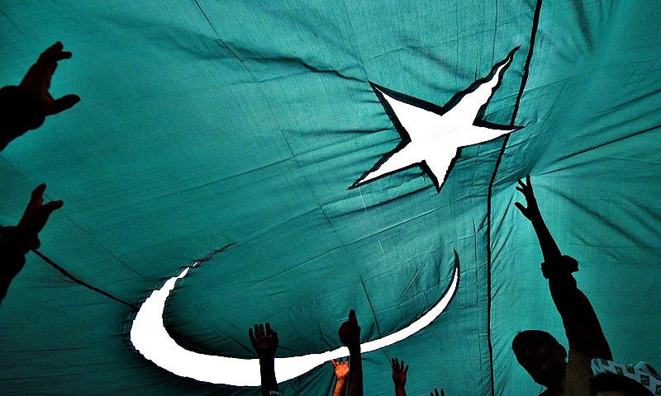

# Power of Pakistan

A

fter many struggles and efforts we got the Pakistan. Allama Iqbal and Quaid-e-Azam (M.Ali Jinnah) played an important role in the creation of Pakistan. Everyone knows the history of creation of Pakistan but in this report I am discussing about main facts of Pakistan.

***Now the defence of Pakistan is how much strong?***

If we discuss about past, we were not too much strong, battle hard, well trained and motivated, but now we are. We did not have too much powerful nuclear weapons, aircrafts and battle equipment but now we have. The India’s tooth will be broken by us (INSHA ALLAH) if they attempt any vulgar movement.

***Opinion of foreigners about past Pakistan :***

Everyone were telling that Pakistan will never escape after 1947 but we got success. After 1971 they were telling that we will never escape. And when we were fighting with Soviet union everyone were telling that Pakistan will never escape this time. When we start our nuclear program then Henry Kissinger came to Lahore and said that we will make a horrible example lot of you. But with the order of ALLAH we are still here and make a horrible example lot of you.

Pakistan is developing advance battle equipment personally and also selling to foreigners. We are making advance aircrafts, drones, tanks, SMG(Sub Machine Guns), LMG(Light Machine Guns), Rocket Launchers and many more battle equipment. The Express Tribune > Pakistan. Pakistan showcased its main battle tank Al Khalid, JF-17 Thunder, Super Mushshak, K-8 aircraft, Fast Attack Craft Missile boats, armoured personnel carriers, premium grade military hardware and related technology

Pakistan showcases defence prowess at IDEAS 2016

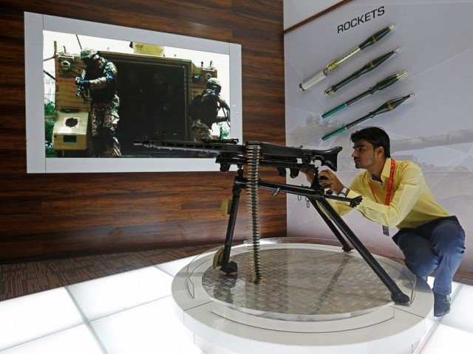

A visitor handles a gun during the Exhibition. PHOTO: REUTERS

Ideas 2016 defence exhibition showcasing the country’s indigenously built military hardware, including fighter aircraft, tanks, missiles, drones, APCs and firearms, came to an end on Friday.

Some 418 firms from 34 countries exhibited their products, of which, 261 were foreign. Delegations headed by defence ministers, secretaries, chiefs of defence staff or services chiefs of respective countries were all present at the much-awaited exhibit.

Here are some of the highlights from IDEAS 2016.

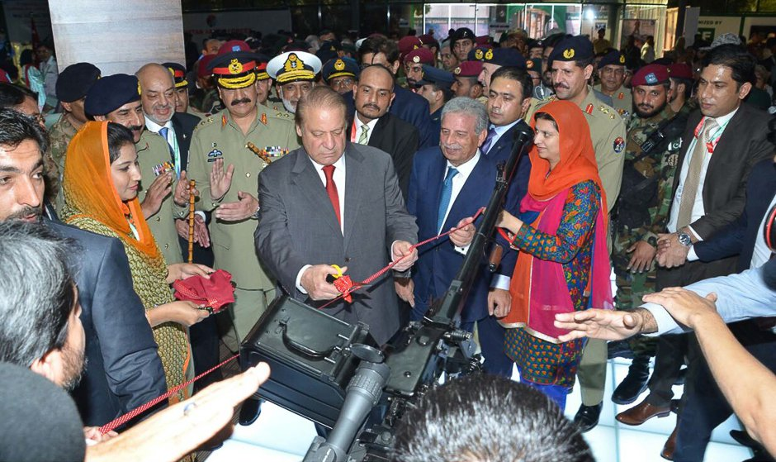

Prime Minister Muhammad Nawaz Sharif cuts a ribbon during the inauguration ceremony.

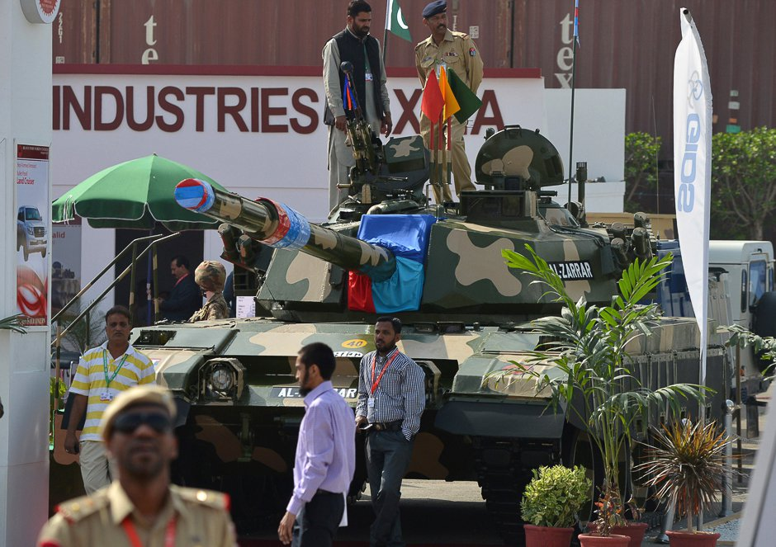

Delegates members look at Pakistan’s Al-Zarrar tank and other artillery.

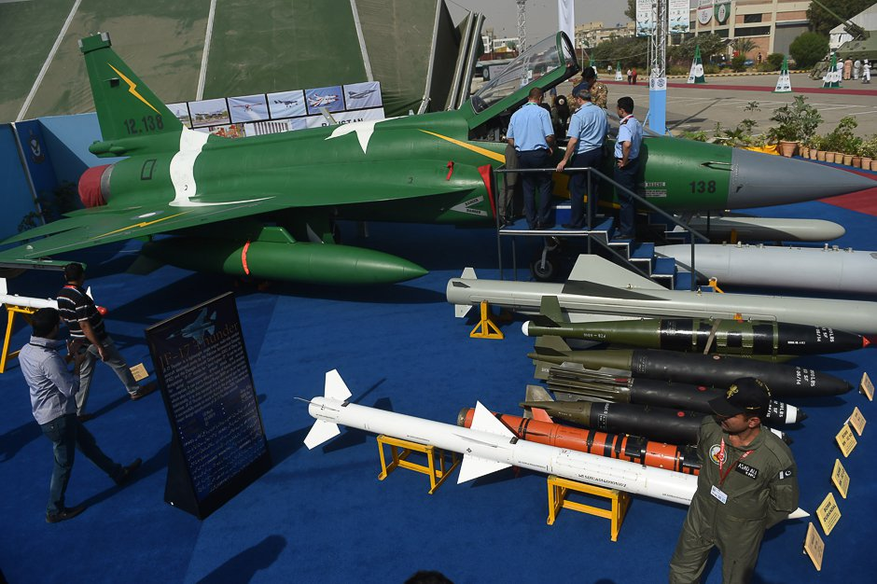

Delegate members look at a Pakistan’s JF-17 Thunder multirole combat aircraft.

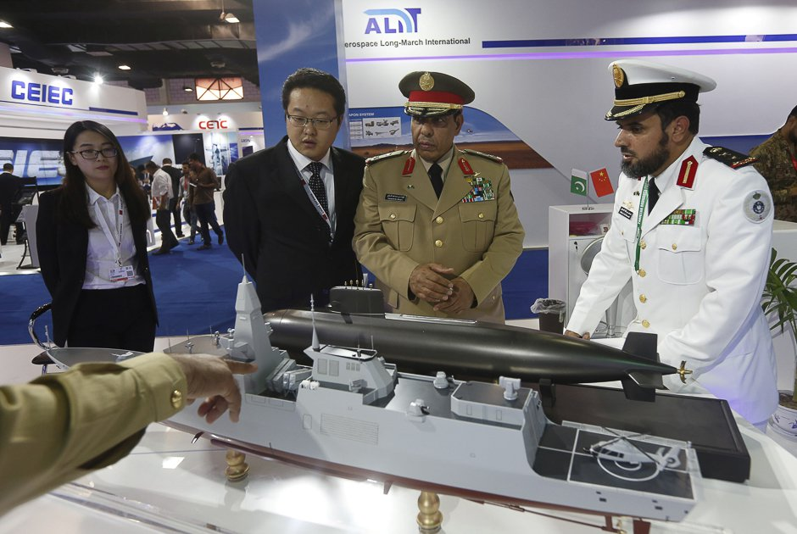

Delegations from foreign countries are briefed by a representative (L).

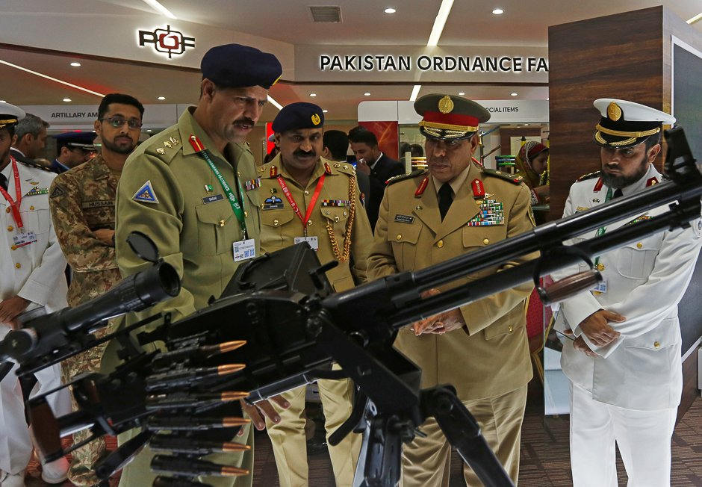

Delegations from foreign countries are briefed by an Army representative (L).

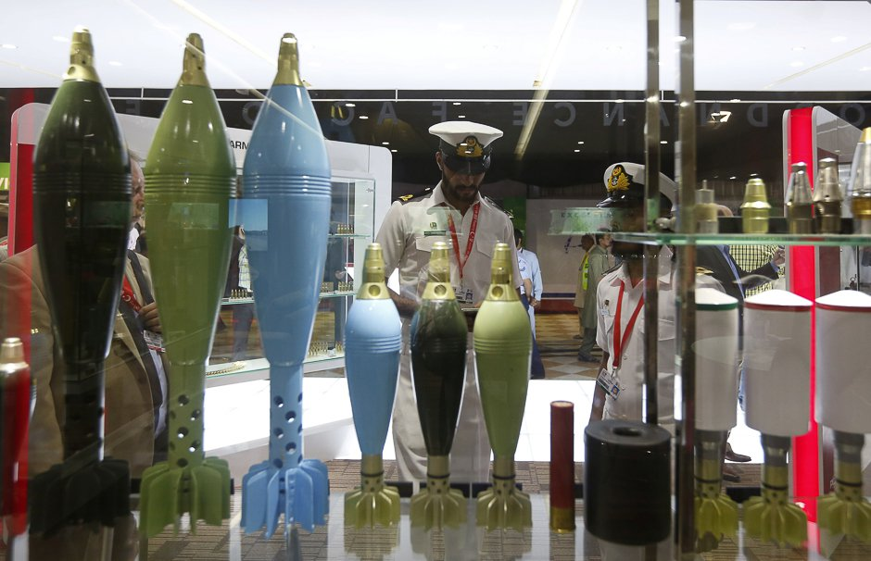

Visitors are seen through the display window showing mortars.

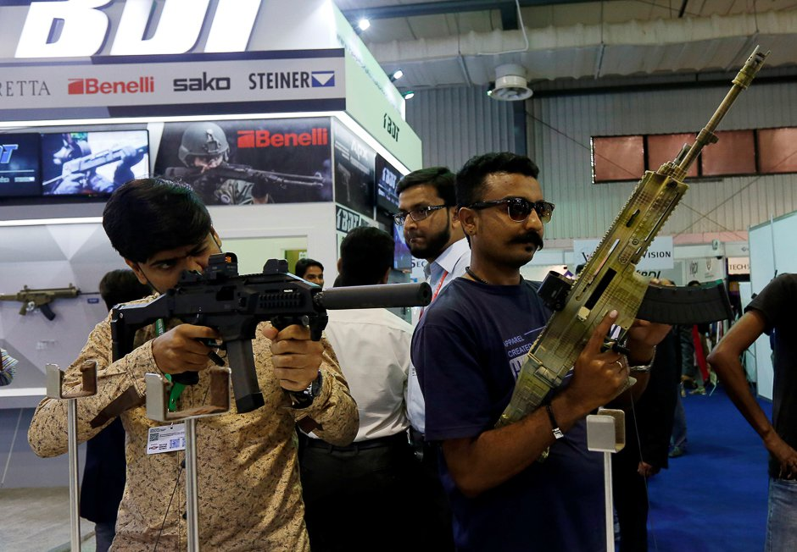

Visitors handle guns during the Exhibition.

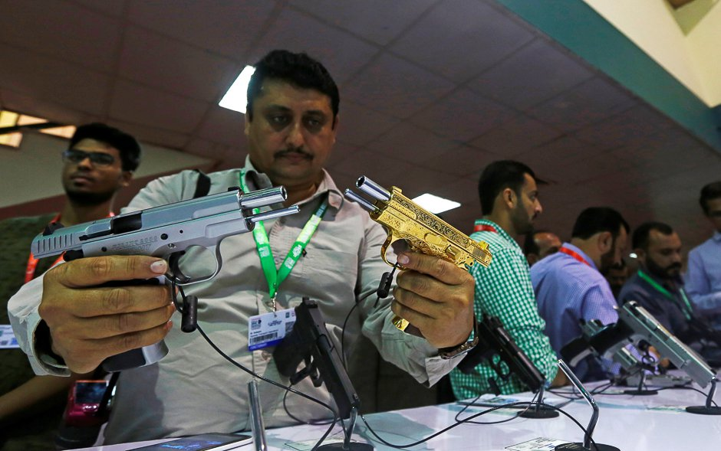

A visitor compares pistols during the Exhibition. PHOTO: REUTERS

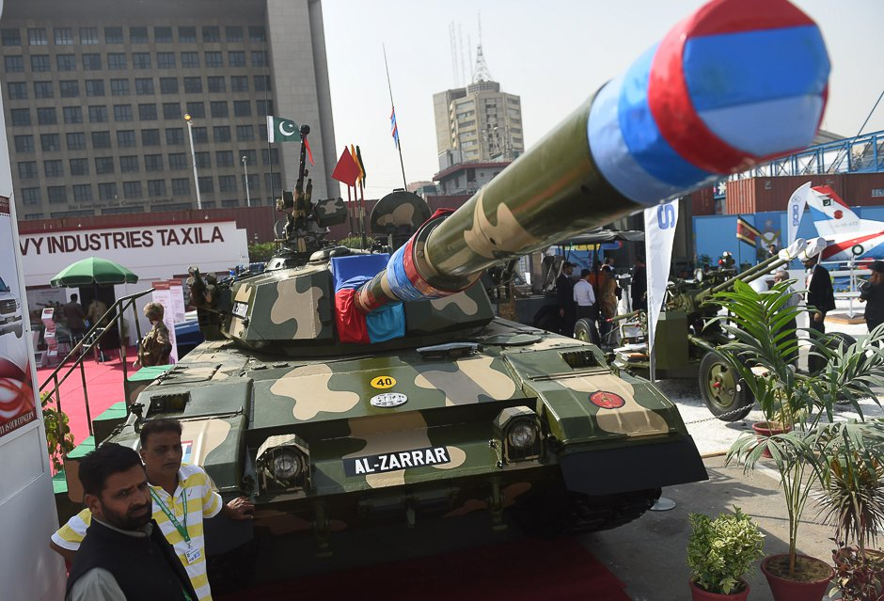

Delegate members look at Pakistan’s Al-Zarrar tank and other artillery.

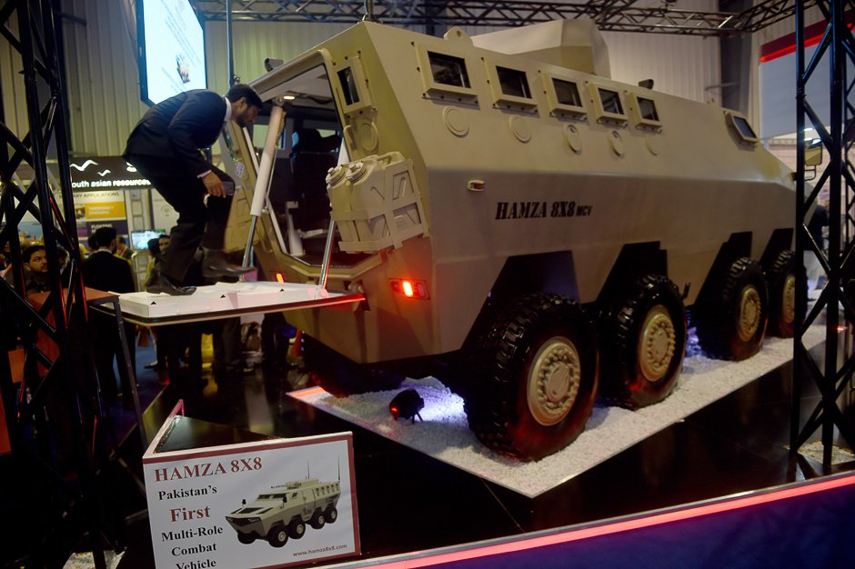

A delegate member looks at Pakistan’s first Multi-Role Combat Vehicle.

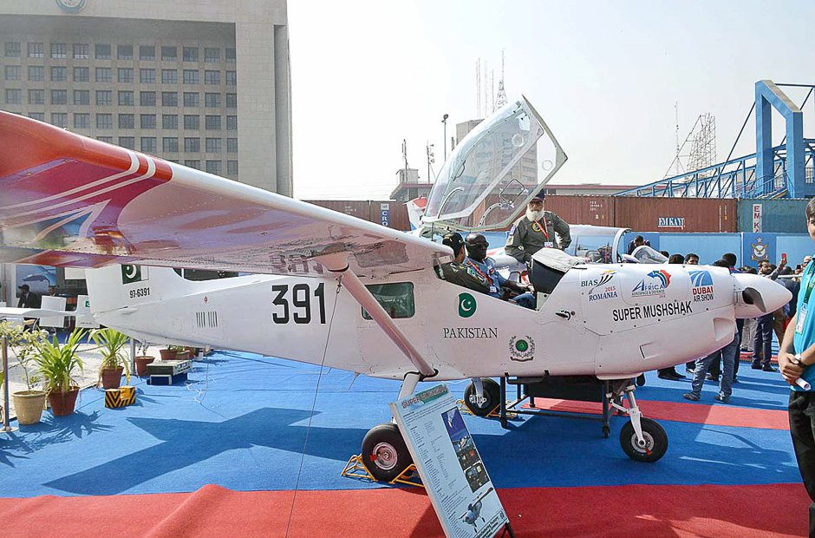

Members of the foreign forces visit the Super Mushshak Air Craft stalls.

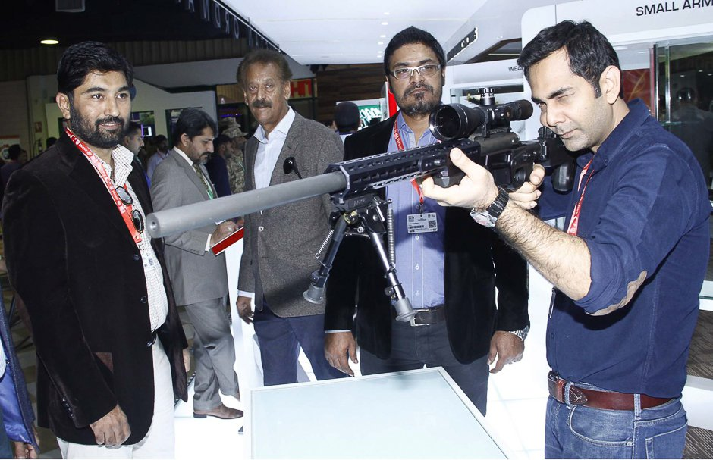

A visitor holds a sniper rifle during the exhibition.

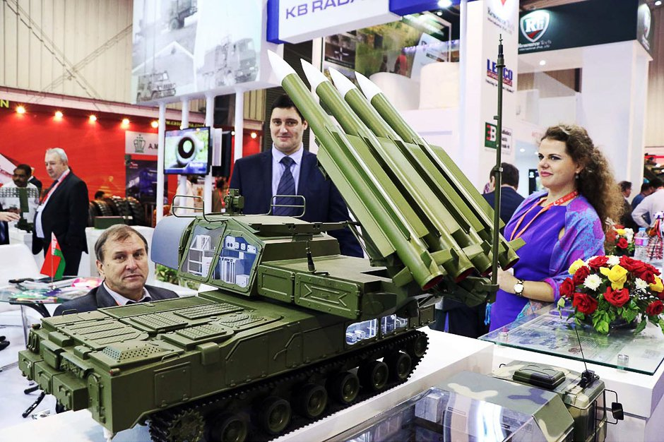

Foreign visitors are seem visiting stalls displaying models of modern military war equipment during the exhibition.

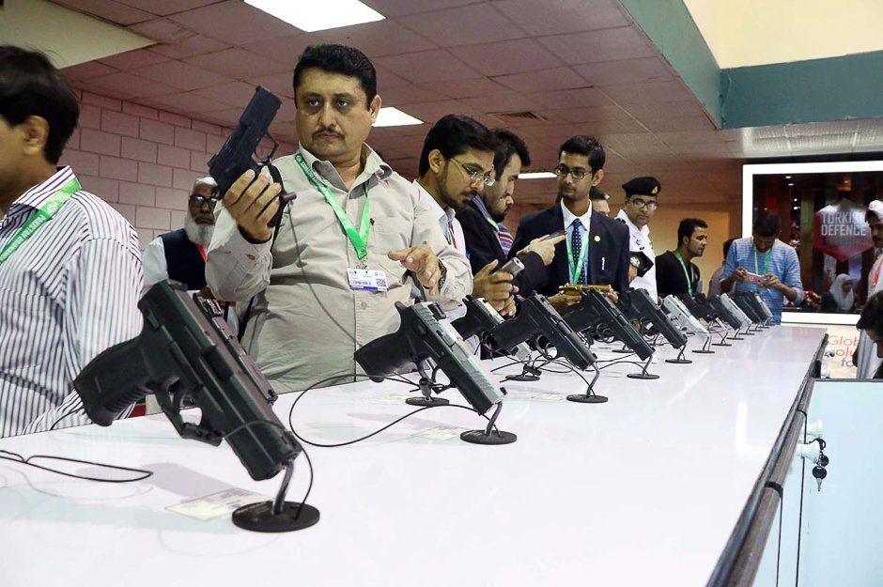

Visitors check handguns at a stall displaying models of modern military war equipment.

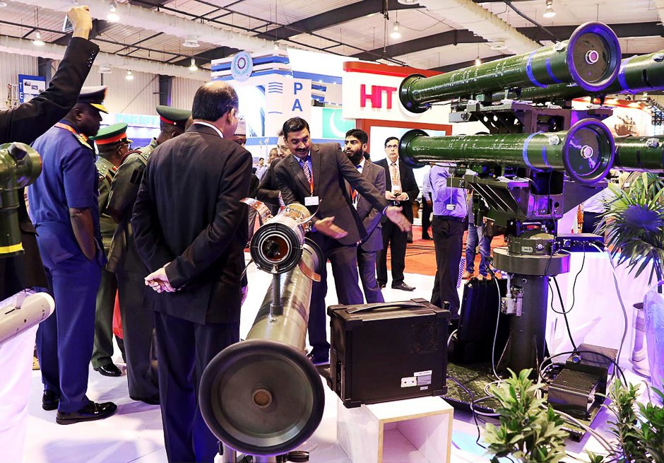

Foreign visitors are seem visiting stalls displaying models of modern military war equipment during the exhibition.



ISI stands for (Inter Service Intelligence). It is the main intelligence agency of Pakistan. Last defence line of Pakistan. This has been ranked as the **world’s best intelligence agency** by the American crime report.The major aim of the agency is to protect national interests, pay heed to matters of political and social interests and advise the military in taking appropriate steps. Safeguarding nation from domestic and foreign enemy attacks along with counter-terrorism steps also highlight the objectives. This agency has played a vital and effective role during Kargil & Afghan Wars and Kashmir operation. A beautiful and motivating video made by ISPR on ISI

Pakistan had start their nuclear program in January 1972 and this programming is still continue. Pakistan is upgrading the quantity and strength of nuclear weapons day by day. Now the Pakistan is not only nuclear power instead the nuclear missiles technology of Pakistan is value able in whole world. Now our nuclear ranking is 6th but we will be on 3rd rank after 5 or 10 years.

Proved by 2 Americans think tanks. I am giving a link in which you can see the report of American think tank about Pakistan nuclear power [####link####](https://www.dawn.com/news/1203181)  Must watch please.

Pakistan’s upcoming satellite missile (TIPU) [Must watch](https://www.youtube.com/watch?v=4efJOX9Zw1c)

***A list of missiles developed by Pakistan.***

* Surface to surface missiles
* Surface to air missiles
* Surface to sea missiles
* Sea to surface missiles
* Air to surface missiles

## Surface-to-surface missiles

[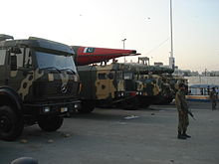](https://en.wikipedia.org/wiki/File:Military_truck_carrying_IRBMs_of_Pakistani_Army.jpg)

Truck-mounted Missiles on display at the IDEAS 2008 defence exhibition in Karachi, Pakistan.

[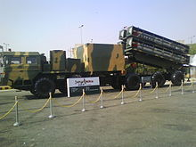](https://en.wikipedia.org/wiki/File:Babur_Cruise_Missle_at_Ideas_2008.jpg)

A transporter erector launcher (TEL), carrying four cruise missiles, on display at the IDEAS 2008 defence exhibition, Karachi, Pakistan.

Battlefield range ballistic missiles (BRBM)

* Nasr
* Hatf-I

Short range ballistic missiles (SRBM)

* Ghaznavi
* Abdali-I
* Ghauri-I
* Shaheen-I

Medium range ballistic missiles (MRBM)

* Ghauri-II
* Shaheen-II
* Shaheen-III
* Ababeel, development of the Shaheen-III with multiple independently targetable reentry vehicle (MIRV)
* **Intercontinental ballistic missiles (ICBM)**
* Tipu/Taimoor (7000 to 10000+ KM)Under development

Cruise missiles

* Babur 1 (Hatf VII)
* Babur 2 (Hatf VII)

Anti-tank guided missiles (ATGM)

* Bakhtar-Shikan

## Surface-to-air missiles

[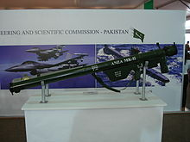](https://en.wikipedia.org/wiki/File:ANZA_MK_2.JPG)

Anza MK-II displayed at an exhibition

* Anza Mk.1, Mk.2, Mk.3

## Surface-to-sea missiles

* Zarb Anti-ship missile

## Sea-to-surface missiles

* Babur 3 (Hatf VII)

## Air-to-surface missiles

* Ra'ad (Hatf VIII)
* Ra'ad-II (Hatf VIII)
* Bakhtar-Shikan
* H-2 SOW
* H-4 SOW
* Barq

# 

The whole world is witness that in which profession or field we get enter. We got success

Such as :



**Arfa Abdul Karim Randhawa** was a Pakistani student and computer prodigy who, in 2004 at the age of nine, became the youngest Microsoft Certified Professional (MCP). She kept the title until 2008. Arfa represented Pakistan on various international forums including the TechEd Developers Conference. She also received the President's Award for Pride of Performance in 2005. A science park in Lahore, the [Arfa Software Technology Park](https://en.wikipedia.org/wiki/Arfa_Software_Technology_Park), was named after her. She was invited by Bill Gates to visit Microsoft Headquarters in the United States. She died on 14 January 2012, aged 16, following a cardiac arrest.

I have many more examples but I can not write anymore. I am giving a link for more successful persons of Pakistan which make Pakistan proud.

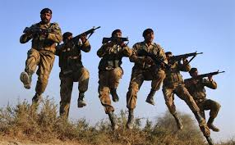

Our army is the most respected and [bravest army](https://www.thetoptens.com/best-ground-force-armies-world/) in the whole world. I am not saying that. This is proved by internet. We are a brand in whole world. Pakistan army had won GOLD MADLE in 2010. Recently in 2015 our Pak army again won GOLD MADLE at an annual international military patrolling exercise, ‘Exercise Cambrian Patrol’ held in the UK.

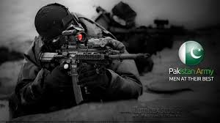***Here is brief detail about Pakistan Army.***

The Pakistan Army is the largest branch of the Pakistan military, and is mainly responsible for protection of the state borders, the security of administered territories and defending the national interests of Pakistan within the framework of its international obligations.   
  
The Pakistan Army, combined with the Navy and Air Force, makes Pakistan's armed forces the 7th largest military in the world (We have seventh largest Army in world). The Army is modelled on the United Kingdom armed forces (the reason you know that we got freedom from UK) and came into existence after the independence in 1947. It has an active force of 520,000 personnel and 500,000 men in reserve that continue to serve until the age of 45.  
  
The Pakistani Army consists of both volunteer and conscripts and has been involved in many conflicts with India (1948, 1965, 1971, 1999). Combined with this rich combat experience, the Army is also actively involved in contributing to United Nations (UN) peacekeeping efforts. Other foreign deployments have consisted of Pakistani Army personnel as advisors in many African, South Asian and Arab countries. The Pakistani Army maintained Division and brigade strength presences in some of the Arab countries during the past Arab-Israeli Wars, and the first Gulf War to help the Coalition.

Our current General is Gen Qammar Jawaid Bajwa. He is performing his best for Pakistan. Our last General, Gen Raheel Sharif was a bravest General in the world. And his ranking is 1st in whole world. General Raheel Sharif declared World best Military Commander. [Watch it.](http://salampakistanio.blogspot.com/2016/01/general-raheel-sharif-declared-best-gereral.html)

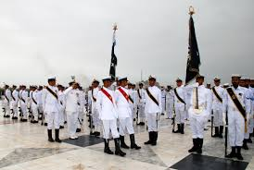Pakistan Navy has always protected our costal borders and defeated the nefarious planes of our enemies. Pakistan Navy is also playing a vital role in insuring stability in the region. Beside commitment to safe guarding the sea frontier of the mother land. Pakistan Navy has always remained proactive in peace building and welfare oriented projects.

Pakistan Navy has mounted the first mini Astro-turf of the country at Abdul Sattar Edhi Hockey Stadium , Karachi. Chief of the naval staff Admiral Mohammad Zakaullah inaugurated the turf.

Speaking on the occasion, the Admiral said: “Pakistan Navy has always strive to promote sport and healthy activities in country and Pakistan Navy is proud for taking initiative to lay first of its kind turf in the country. He also expressed his hope that this Mini Astro-turf will facilitate in grooming the young players so as to bring back the lost laurels in the games of Hockey.

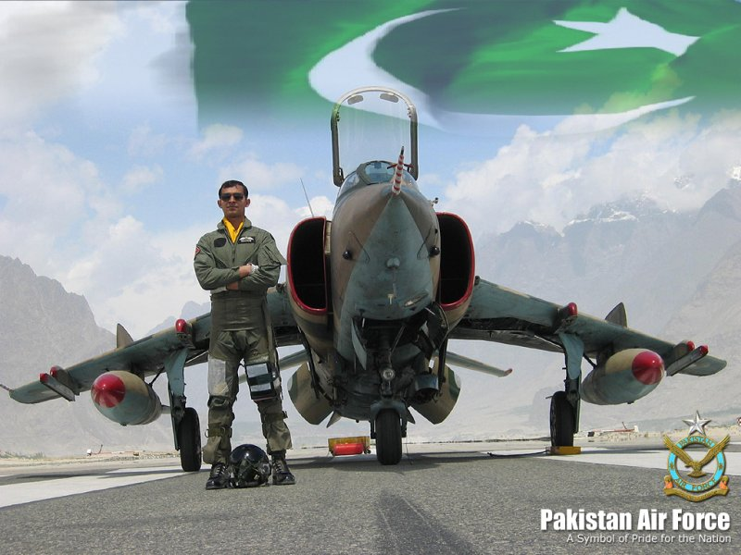

Pakistan air force numerates in world best air forces because off acquirement increasing day by day. Now we have most powerful and advance aircrafts. We have long range air defence radar. We have air refueling capability. We have bravest and extra ordinary pilots in our air force with full of nerve and mettle. If we talk about (Mr.M.M.Alam). He made a classical record which is unbreakable. He destroyed 5 Indian fighter jets in less than 30 seconds and made them hell conjunctive. If we go little bit ahead and discuss about 1967 when Israel was attacked on 3 Islamic countries (Jordan, Egypt and Syria) without any announcement or warning of war. They had destroyed the army and air force of these Islamic countries. Then these Islamic countries were demanding help from Pakistan. Then the Pak air force went to Israel and mixed the Israel’s arrogance in soil. In 1974 Israel attacks on Arab and again Pakistan defends an Islamic country (Arab). In 1995 Pakistan defends Bosnia.

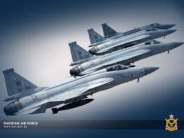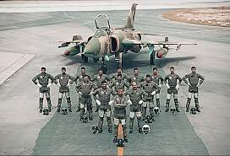

### Skills of our Pakistani pilots.

After few months ago our pilots were practicing of air craft landing on motorway and they had done successfully ,India was also trying to imitate us but they failed. What were Indian pilots saying after this unsuccessful attempt. Seriously, this is the condition of India and they say about battle with Pakistan. This is a nation who dread from a sweet & cute pigeon.

Though the geography of the country is same, the interpretations of interests linked with it have improved a bit with the changing regional and international dynamics. This can be evaluated under the following new heads:

**China-Pakistan Economic Corridor**  
The $46 billion ‘China-Pakistan Economic Corridor’ scheme, which is being demonstrated as a ‘Game-Changer’ is more than a network of roads to link Chinese city of Kashgar with the Gulf States via Gwadar of Pakistan. CPEC is a complete package of energy projects and trade opportunities for Pakistan. It is the most cherished fruit of Pakistan’s geographical importance the country ever had. However, some credit also goes to the foreign policy makers of Pakistan who always kept into considerations the Sino-Pak mutual interests.

In the wake of CPEC, China is going to have the shortest route-access ever available to the Middle Eastern, African, and European markets. For Pakistan, it might be a new gain but to China, this access is a link to it long term strategic plan to take over US control in the said regions.

Gwadar port is the nearest warm-water port to energy-rich Central Asian Countries  
Bought from Oman in 1958, Gwadar has been developed into a warm-water seaport which now operated by a Chinese company named ‘China Overseas Port Holding Company’ under a 43 years agreed lease. The port is the soul of China-Pakistan Economic Corridor. Being the nearest deep-sea port to the landlocked Central Asian Republics, Gwadar is another manifestation of Pakistan’s geographical importance

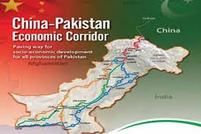

**The Persian Gulf and Pars Gas Field**  
Pakistan’s Gwadar Port provides access to the ‘Gulf of Oman’ which extends via ‘Strait of Hormuz’ to form the ‘Persian Gulf’. This gulf is surrounded by Iran, UAE, Saudi Araba, Bahrain, Qatar, Kuwait and Iraq. Access to the Persian Gulf via Gwadar port means access to all these countries most of which are rich in energy resources. The Persian Gulf also has the world’s largest natural gas reservoir ‘Pars Gas Field’ shared by Iran and Qatar. Pakistan’s geographic importance increases due to its proximity to such mega-fields of natural resources when the country has been suffering from energy starvation for long periods of time.

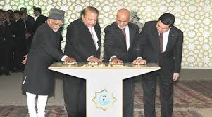**Turkmenistan-Afghanistan-Pakistan-India Pipeline (TAPI)**  
The Asian Development Bank’s funded project of TAPI is the name of a gas pipeline which aims to supply natural gas from the Caspian Sea to the four countries mentioned above. Pakistan due to its geographical nearness to this Central Asian Republic is seeking benefit from the project. It also reflects the dependence of India on Pakistan for having access to the natural resources of Central Asian Republics. The construction of the project commenced in December 2015, and it will be functional by 2019.

**Iran-Pakistan Gas Pipeline**  
Also known as the ‘Peace Pipeline’ the project is another fruit of Pakistan’s geographic importance. The pipeline project was formally inaugurated in 2013, but it’s far from being operational due to several controversies. Particularly the anti-Iran stance of the USA influenced Pakistan to abandon the project. Things, however, have changed after the US-Iran Nuclear Deal and Iran is no more under enormous sanctions. Pakistan at the same time never utterly gave up the project. Good omens are apparent for the future of this project.

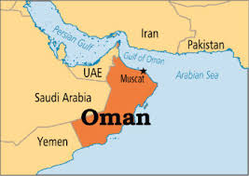**Pakistan shares Marine Border with Oman**  
Pakistan and Oman settled their maritime under an agreement in 2000; adhering to the International Law of Sea. This sharing of a maritime boundary with the brotherly country of Oman can interpret Pakistan’s geographical importance in the sense of access to Oman’s undersea energy resources. The sea route can also be used to have access to the Persian Gulf and its littoral states.

**Karachi port:** The Port of Karachi (Urdu: کراچی بندرگاہ‎ Bandar is one of South Asia's largest and busiest deep-water seaports, handling about 60% of the nation's cargo (25 million tons per annum) located in Karachi, Pakistan. It is located between the Karachi towns of and Saddar, close to the main business district and several industrial areas. The geographic position of the port places it in close proximity to major shipping routes such as the Strait of Hormuz. The administration of the port is carried out by the Karachi Port Trust, which was established in the 19 century. 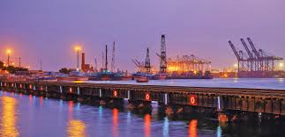

**Jinnah International Airport:**  Jinnah International Airport has a capacity of handling 12 million passengers annually. In fiscal year 2008–2009, over 5,725,052 passengers used Jinnah International Airport. 50,095 aircraft movements were registered.[8] Jinnah International Airport in Karachi has always been the largest aviation facility in Pakistan. It is the primary hub of Pakistan International Airlines (PIA). All other Pakistani airlines also use Jinnah International Airport as their main hub. These include airblue and Shaheen Air, as well as several charter carriers. The building is linked via connecting corridors to two satellites, each having a provision of eight passenger-loading bridges. The eastern satellite is devoted exclusively to handling international operations.

Pakistan is well-known for its beautiful Northern areas. These areas are truly called a visitor’s paradise. Pakistan has some of the world’s most beautiful valleys in its Northern areas having alpine flowers, fairy meadows, turbulent rivers and snow-covered mountains. Here brief description of some beautiful valleys is given with a view that it would definitely stimulate you to visit them.

**Hunza Valley**

[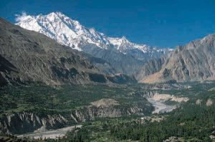](https://mojotravel.files.wordpress.com/2011/01/hunza_valley.jpg)Hunza Valley is among one of the most popular valleys among tourists. Its major town Karimabad has some of the beautiful and elegant peaks in world including Rakaposhi, Passu Peak, Hunza Peak. Especially the view of Rakaposhi is worth-seeing in moon-light. Another attraction of Hunza is the Baltit Fort that gives an awesome ancient touch. Most of the tourists come here to see these two big attractions. Moreover Hunza provides the tourists a pleasure of trekking and hiking.

**Gilgit Valley**

[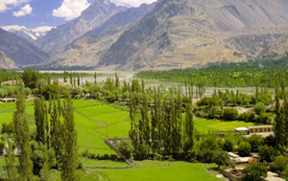](https://mojotravel.files.wordpress.com/2011/01/gilgit-valley.jpg)Gilgit Valley is also considered as one of the finest valley of Pakistan. It is located at an elevation of 1454 meters. Gilgit is not only known for its beauty but also for a number of historic places that are worth-visiting. Some of the attractions in Gilgit Valley include:

* Budha Sculpture engraved out of stone
* Taj Mughal (30 KMs from Gilgit town)
* Sher Qilla
* Naltar Valley( at a three hours drive from Giligit link road where you enjoy services of rest-house and various private hotels, alpine forest and a Ski slope)
* For those tourists who like to play and watch Polo, Giligit is the best place to visit. A Polo tournament is held in Gilgit valley every year in the month of November.

Like other Northern valleys of Pakistan, Giligit valley is also perfect of trout fishing, trekking, hiking and mountaineering

.

**Kaghan Valley**

Visiting Kaghan valley proves to be a wonderful and[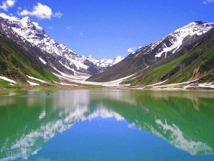](https://mojotravel.files.wordpress.com/2011/01/pic_kaghanvalley-saifulmalook.gif) memorable experience. It is located in the province of Khyber PakhtoonKhwa. It is popular for its lakes, streams and gorgeous water-falls but is mostly known for its one lake named Saif-ul-Maluk.  It is among one of the most stunning lakes of Pakistan.

Here in the waters of this valley, world’s renowned fishes are found named Trout and Mahasheer. Especially the trout of River Kunhar is very popular among tourists and locals as well.

**Skardu Valley**

[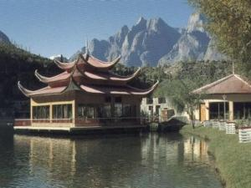](https://mojotravel.files.wordpress.com/2011/01/shangrilla_skardu_1_galleryfull.jpg)Skardu is the main town and capital of Baltistan which is situated in the background of Karakoram Mountains range. The journey from Islamabad to Skardu by air is full of enthusiasm as it provides a breath-taking view of the high mountains. Its attractions include Buddhist Rock, Sadpara Lake, Kachura Lake, Shigar Valley and Khaplu Valley.

**Swat Valley**

[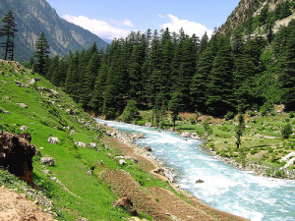](https://mojotravel.files.wordpress.com/2011/01/swat-valley-pakistan.jpg)Swat valley is considered perfect for spending holidays. It is full of beautiful views of cold lakes, slopes covered with beautiful flowers and gardens full of fruits-laden branches. It is located at an elevation of 975 meters. It is the only valley where the tourists can go at any time of year as its weather is not as extreme as compared to other valleys.

This was some information and description about some of the valleys located in Northern areas of Pakistan providing a clear picture of their beauty.